Scottish Paediatric & Adult Infection & Immunology Network (SPAIIN)

Paediatric Hepatitis C Pathway

NOTE
This guideline is not intended to be construed or to serve as a standard of care. Standards of care are determined based on all clinical data available for an individual case and are subject to change as scientific knowledge and technology advance and patterns of care evolve. Adherence to guideline recommendations will not ensure a successful outcome in every case, nor should they be construed as including all proper methods of care or excluding other acceptable methods of care aimed at the same results. The ultimate judgement must be made by the appropriate healthcare professional(s) responsible for clinical decisions regarding a particular clinical procedure or treatment plan. This judgement should only be arrived at following discussion of the options with the patient, covering the diagnostic and treatment choices available. It is advised, however, that significant departures from the national guideline or any local guidelines derived from it should be fully documented in the patient’s case notes at the time the relevant decision is taken.
Contents
Paediatric Hepatitis C virus (HCV) 3
Perinatal HCV transmission 3
Testing of infants born to Hep C RNA PCR positive women 3
Testing of children 3
Monitoring of paediatric HCV 4
Treatment of paediatric HCV 4
Appendix A: Infant HCV testing algorithm (NSD610-019.16) 6
Appendix B: Paediatric and Adolescent Hepatitis C (HCV) National MDT Assessment and Referral Form 7

Paediatric Hepatitis C virus (HCV)
- Mother to child transmission rate for HCV is around 4-6%, and there are currently no proven obstetric interventions which can modify the risk of transmission
- Advances in HCV treatment have resulted in up to 98% cure rates. Paediatric formulations of treatment are now licensed from 3 years of age. Treatment is safe and effective for children
- All children with HCV should be followed regularly in clinic, liver health and viral status should be monitored and they should be offered treatment as soon as reasonably possible

Perinatal HCV transmission
- Currently universal testing of pregnant women has not been adopted
- Individual health boards and hospitals are offering selective antenatal screening strategies
- Only women who are found to be RNA PCR positive during pregnancy are viewed as at risk of perinatal transmission

Testing of infants born to Hep C RNA PCR positive women
See Appendix A for algorithm
- All infants should be tested at 18 months of age with a HCV antibody test
- If antibody positive, a HCV PCR should be added
- If antibody positive and PCR negative, a further antibody and PCR check at 24 months should be arranged
- If antibody persists at 24 months or PCR positive at either point please refer onto/discuss with local paediatric hepatitis services

Testing of children
- Due to current selective and variable nature of HCV antenatal testing strategies across Scotland, there will be an unknown number of infected women not diagnosed in pregnancy whose children are not identified as at risk
- Clinicians are advised to have a low threshold for offering testing to children particularly if there is:
  - unexplained increase in liver function tests
  - maternal/paternal history of current /past IV drug use
  - maternal history of having spent time in prison
  - maternal history of blood transfusion prior to 1992
  - child or maternal history of overseas invasive procedures (dental, surgical, immunisation), blood transfusions or tattoos/body piercing, if sterility of equipment in doubt
  - child or maternal history of coming from an area of high prevalence – Egypt, southeast Asia, Africa, southern and eastern Europe

Monitoring of paediatric HCV
- Most children with HCV are well with no clinical stigmata of illness with normal or mildly elevated liver function tests
- The natural history of HCV infection in children is rarely associated with severe or decompensated liver disease during childhood, but the infection persists for many years, causes chronic hepatic damage, and may be responsible for significant morbidity and mortality later in life
- Children with HCV should be reviewed every 6 months with a check of viral load (PCR), liver health (FBC, LFTs, coagulation) and an abdominal US every 2-3 years. Where available, a fibroscan is increasingly used to monitor for the development of liver fibrosis
- Please enter all children with HCV onto the paediatric HCV instance of CAS (Clinical Audit System)
- Children with HCV should be considered for treatment as soon as reasonably possible. Currently treatment options are licensed from 3 years of age
- The offer of treatment should be discussed with parents including the efficacy of treatment, the importance of adherence, the ability to swallow tablets, the low potential for side effects, treatment duration and post treatment assessment of viral clearance
- Baseline treatment assessment should include details of co-existent bowel diseases causing malabsorption, co-existent blood borne viruses, current medications and potential interactions, HCV genotype and liver health - see appendix B for pre-treatment proforma

Treatment of paediatric HCV
- Treatment options for children have and continue to evolve rapidly
- European guidance is available https://easl.eu/wp-content/uploads/2020/10/EASL-recommendations-on-treatment-of-hepatitis-C.pdf
- The SPAIIN paediatric HCV treatment MDT is available to discuss treatment options for all children with HCV and formulate treatment plans. MDT meets monthly (via teams on fourth Wednesday of the month) and is led by Fiona Marra (lead clinician for SPAIIN), Alison Boyle (advanced BBV pharmacist), Conor Doherty (paediatric infectious disease specialist) and Debbie Thomson (paediatric BBV CNS)
- Duration depends on regimen, prior treatment history, presence of fibrosis/cirrhosis
- Licensed treatment options

Drug | Genotype | License | Dose
Epclusa® (Sofosbuvir/velpatasvir) | Pangenotypic | 3+ years | ≥ 30kg: 1 x 400mg/100mg tablet once daily or 2 x 200mg/50mg tablet once daily or 2 x 200mg/50mg sachets of granules once daily
 |  |  | 17 to < 30kg: 1 x 200mg/50mg tablet once daily or 1 x 200mg/50mg sachets of granules once daily
 |  |  | < 17kg: 1 x 150mg / 37.5mg sachets of granules once daily
Maviret®  (Glecaprevir/pibrentasvir) | Pangenotypic | 3+ years and ≥ 12 kg | 12+ years and children ≥ 45kg:  3 x 100mg/40mg tablets once daily
3+ years and 12 to < 45kg:
50mg/20mg granules in sachet
≥12 to < 20kg: 3 sachets (150mg/60mg) once daily
≥20kg to < 30kg: 4 sachets (200mg/80mg) once daily
≥30 to < 45kg: 5 sachets (250mg/100mg) once daily

Harvoni® (Ledipasvir/sofosbuvir) | 1, 4, 5, 6 | 3+ years | ≥ 35kg: 1 x 90mg/400mg tablet once daily or  2 x 45mg/200mg tablet once daily or  2 x 45mg/200mg sachets of granules once daily
 |  |  | 17 to < 35kg: 1 x 45mg/200mg tablet once daily or 1 x 45mg/200mg sachet of granules once daily
 |  |  | < 17kg: 1 x 33.75mg/150mg sachet of granules once daily

Appendix A: Infant HCV testing algorithm (NSD610-019.16)
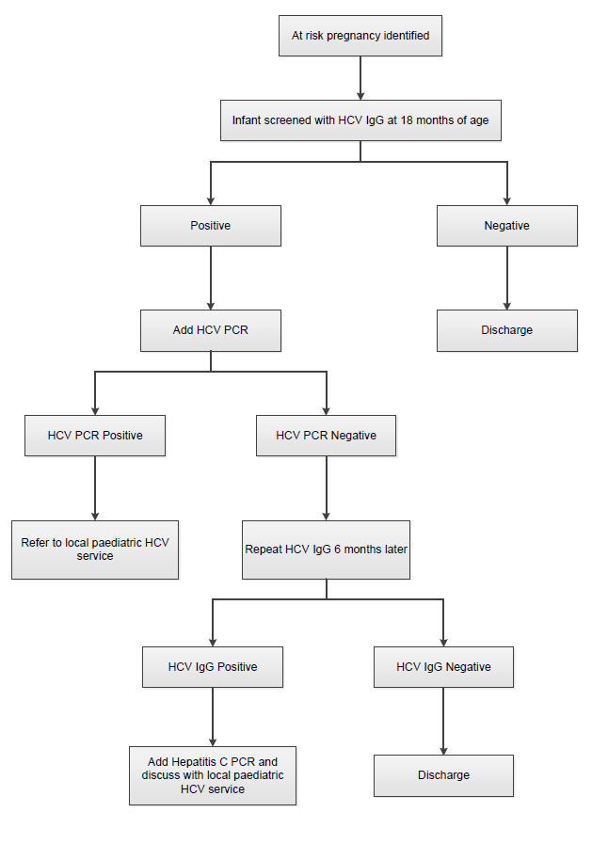

Appendix B: Paediatric and Adolescent Hepatitis C (HCV) National MDT Assessment and Referral Form

CHI:  Initials: | Date of Assessment:
 | BBV Screen  (within 6 months prior to treatment start) | Neg | Pos | Date of Test
Previous HCV Treatment Yes □ No □  If Yes, provide details:__________________ | HIV antibody
 | HBsAg
Disease Stage | anti-HBc antibody
 |  | Result |  | Date of Test
Fibroscan Yes □ No □ N/A □  If Yes, result and date: ___________________________________ | Anti-HBs
 | HCV PCR
 | HCV Genotype
 | Other pre-treatment results | Result |  | Date of Test
Liver ultrasound Yes □ No □ N/A □
If Yes, result and date:
___________________________________
 | Platelets
 | Hb
 | ALT
Current Medication including OTC/herbal/illicit drugs:  Community pharmacy details: | AST
 | Bilirubin
 | Albumin
 | Alk Phos
 | AFP
 | eGFR
 | Coag | Normal □  Abn □
 | Weight
Co-morbidities: | Social situation:  Alcohol/drug use: Yes □ No □ NA □
Contraception: | Pre-treatment assessment:
Sexually active Yes □ No □ NA □ | Able to swallow tablets? Yes □ No □  If no, arrange swallow assessment.  Responsible adult to supervise treatment? Yes □ No □  Ensure discussion re: efficacy, importance of adherence, side effects, follow up, potential for drug interactions
Using contraception Yes □ No □ NA □
Pregnancy Test Yes □ No □ NA □
Discuss (if applicable): Options/access to contraception, implications of pregnancy during treatment
Follow up:
Telephone review at week 2 and 4 (or 6 weeks if 12 week treatment)
Appointment for review/bloods at end of treatment and 12 weeks post treatment (SVR 12)

Repeat LFTs if abnormal pre-treatment or anti-HBc antibody +ve
HIV antibody if ongoing BBV risk factors

Paediatric HCV MDT advice:
Date discussed:
Advice:

